**SHS Theatre Spring Musical Information Packet- BIG FISH 2025**

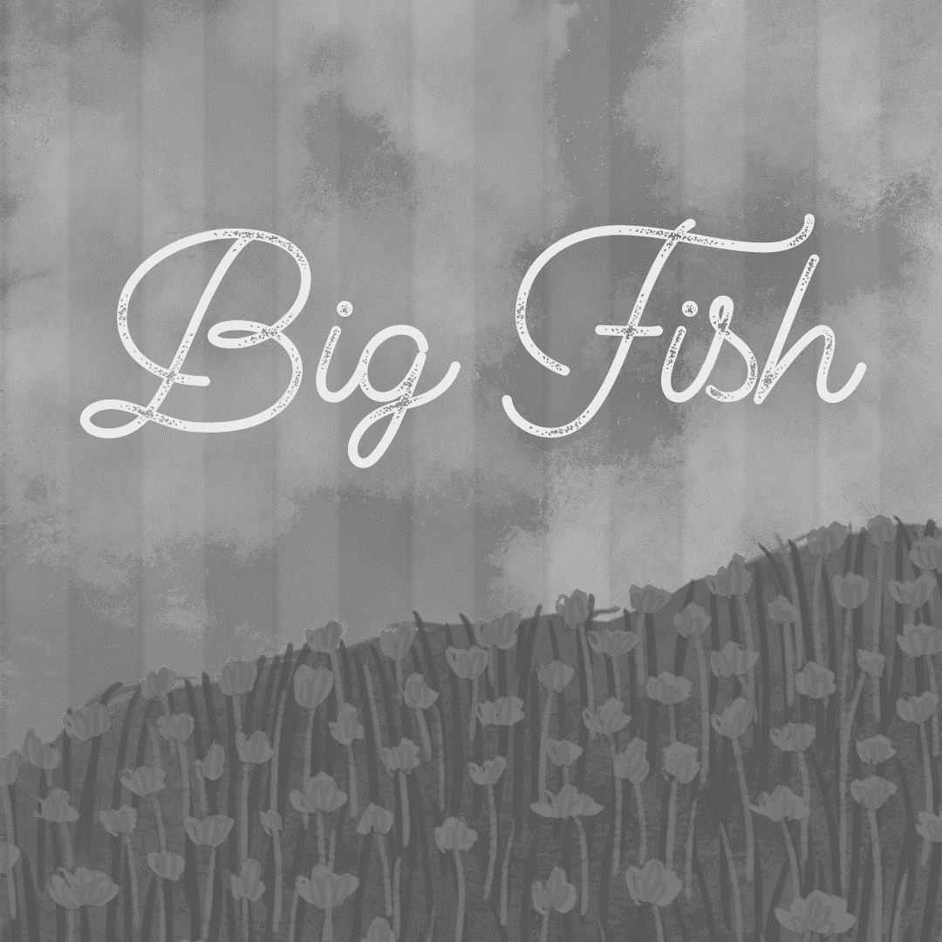

**Student Performer: ____________________________**

**December 16 individual audition time: _______________**

**Sarasota High School Theatre Spring Musical Info Packet**

Show/Dates: **"Big Fish” April 2-5, 2025**  
​Based on the celebrated novel by Daniel Wallace and the acclaimed film directed by Tim Burton, BIG FISH tells the story of Edward Bloom, a traveling salesman who lives life to its fullest…and then some! Edward’s incredible, larger-than-life stories thrill everyone around him—most of all, his devoted wife Sandra. But their son Will, about to have a child of his own, is determined to find the truth behind his father’s epic tales. Overflowing with heart and humor, BIG FISH is an extraordinary musical that reminds us why we love going to the theatre—for an experience that’s richer, funnier and bigger than life itself.

**Audition dates:**  
**Monday, December 16, 3-6pm**- Individual Auditions  
Everyone must audition on this date. All performers are asked to prepare a short 1-3 minute monologue and sing 16 bars of a song of their choice.  
**Tuesday, December 17, 3-8pm-** Dance call and callbacks

Everyone MUST attend the dance call from 3-4:30. If you are called back for a specific role, you will be given sides before you leave on Tuesday. Callbacks are from 4:30-8 pm and only those who are called back will need to stay.  
  
**How to audition:**  
1. Take a moment to read through our auditions disclaimer and check out an example of our production contract (included in this packet), that way you are familiar with the commitment we will be asking you to agree to. Look doable to you? Fabulous, now to the fun stuff!

2. All parents must sign the audition disclaimer to confirm they are aware of their student participating in “Big Fish”.  
3. Fill out the online audition application. You can find this at shstheater.com, under the “audition materials” tab in the Student Portal.  
4. After you fill out your application, sign up for your five-minute audition time slot. (also on the website)  
5. Choose a 1-3 minute monologue to share with us at your audition. This monologue should be memorized if possible, but it's okay if it is not. (If you have previously performed with us in the past, we expect it to be memorized.) Be prepared to sing 16 bars of a song of your choice- please bring your music clearly marked for our accompanist.

6. Fill out the conflict form. Bring this form with you on the day of auditions.

Please see Ms. K with any questions about our audition process. Break a leg, everyone!

**Big Fish Character Descriptions/Vocal Breakdowns**

*Please take note for the dance callback:*

*• Tumbling is a plus – if you can tumble or pull tricks, please share!*

*• Please wear closed toed shoes for the dance callback and wear something you can move in. NO SKIRTS OR DRESSES, PLEASE.*

*\*\*\*A NOTE ON CASTING- The licensing agreement allows directors to cast characters flexibly in terms of gender, so all characters are available to all actors.*

-*It is possible that we will cast Old and Young versions of Edward, Sandra, and possibly Jenny- if possible we will avoid it, though. For Edward and Sandra, the potential song division is listed below. All cast members will appear in surprising ways throughout the entire show!*

**Edward** – A charming, charismatic storyteller. A devoted yet absent father nearing the end of his life and wanting to reconnect with his son. He is comfortable in his own skin, but hopes for Will’s approval. He loves his wife, his son, and telling stories. Needs a big voice and serious character acting. Plays ages ranging from young father to older sick man. Songs: Be the Hero, Red White and True, Fight the Dragons, Showdown, What’s Next, How It Ends

**Young Edward** – An enthusiastic, optimistic, energetic romantic. Very charismatic, a good salesman. He is the quintessential hometown boy hero. Needs a big voice. Plays ages ranging from high school to late 20s/early 30s. Very good mover. Songs: Out There on the Road, Time Stops, Closer to Her, Daffodils, Red White and True, Start Over

**Sandra** – Patient, calm, the perfect balance to Edward’s enthusiasm. She adores and appreciates Edward and tries to bring reconciliation to her husband and son. Strong singer and actor. Songs: Two Men in My Life, I Don’t Need a Roof

**Young Sandra** – A sweet, innocent young girl excited by the possibilities of life. She appreciates Edward’s romantic viewpoint. Strong singing and dance ability. Songs: Alabama Lamb, Time Stops, Daffodils, Red White and True

**Will** – An earnest, thoughtful young man wanting to reconnect with his father, but unable to appreciate Edward’s romantic view of life. He is a successful professional, new husband, and expectant father. Strong tenor voice and dramatic actor.

**Young Will** – To play approximately 10 years old. Edward’s son, precocious and intelligent. Is told all of Edward’s fantastic tales, isn’t quite sure if they’re real.

**Josephine** – Will’s wife. Successful, intelligent, new bride and expectant mother. Josephine acts as the bridge between Edward and Will.

**Karl** – Edward’s best friend. Karl is shy, exceptionally intelligent, hermit-like, and has a quiet charisma. He needs a booming voice and large personality. Bass. Will need to be comfortable walking on stilts.

**Amos** – Eccentric owner of the circus that employs young Edward. Aldo, a werewolf. Strong, outgoing personality and humor.

**Witch** – Mysterious and knowledgeable. Convinces Edward to pursue a big life without fear. Big belt voice.

**Young Jenny Hill** – Edward’s devoted, first girlfriend. A dreamer. Big voice and dance ability.

**Adult Jenny Hill** – Very tired, disillusioned version of the younger Jenny. She has dignity and honesty. She is crucial in helping Will understand Edward and Edward’s motivations. Serious acting role.

**Don Price** – Snarky bully. Sandra’s first fiancé.

**Zacky Price** – Nerdy brother and shadow of Don Price.

**Doctor Bennett** – Warm, kind, but frank. Edward’s friend and physician.

**Alabama Lambs** – Young Sandra’s friends. Perform with Sandra at the circus. Strong singing and dance skills.

**Others*:***

*(Most have solo lines, all have featured moments and will pop up throughout the entire show.)*

Will’s Son

Mermaid

Witches

Circus Performers

Fisherman

Ashton Mayor

Ashton Residents

University Students

Young Scouts

Dancing Fire (hopefully en pointe)

USO Girls (tap dancers)

General Patterson

Red Fang

WWII villain

WWII Soldiers

Cowboys/Saloon Girls

Old West Judge

Doctors and Nurses

**BIG FISH Auditions Checklist**

Use this to keep track of all you need to do to prepare for and audition for Footloose!

* Read the example of a production contract and familiarize yourself with what you will be committing to.
* Fill out online application
* Sign up for audition time slot
* Choose a monologue
* Choose music
* Mark sheet music for accompanist
* Memorize monologue
* Turn in parent auditions disclaimer at your audition
* Fill out conflict form, being clear and honest about any and all conflicts/scheduling issues
* Turn in conflict form at auditions on December 16

**Big Fish Auditions Disclaimer and Parent Permission Form**

-Please understand that auditioning for a show here at SHS indicates that you are willing to put in a significant amount of time and effort with our program. Most shows rehearse at least four days a week, and that bumps up to every day during tech weeks (the last two weeks before a show goes up). Some nights/weekends are required as well.

-We use a large panel of judges that includes teachers and alumni, as well as community members, to be sure the casting process is fair and equitable. Other factors considered during casting are: past production etiquette and behavior, grades, time needed off for other commitments outside of theatre, reliability, class behavior and etiquette, teacher recommendations, professionalism related to previous casting experiences, as well as countless other factors that parents and students are not aware of due to the sensitivity of subjects. We are proud of our casting choices over the years and stand by them with pride and integrity.

-Other requirements may include: Production fees, shop hours, mandatory fundraising, etc.

***-All cast and crew are required to stay and strike the set closing night of the show.***

**Student name: ______________________________________________________**

**Please Initial if you agree:**

**_______**I understand my student is auditioning for a high school production of “Big Fish” at Sarasota High School. I understand these shows require after school commitment and I have read the example of a production contract and can agree to the requirements within.

**______** I understand the staff, administration, and judging panel decisions are final, and that casting is done as fairly and equitably as possible.

**______** If my student does not wish to accept the role they are offered, I understand they have 24 hours to decline without penalty. I understand SHS Theatre has a culture of respect and honor, and questioning casting choices, gossiping, or bullying staff and students after casting jeopardizes our theatre family.

**____________________________ _______________________________ _____________**

Parent/guardian Name Parent/guardian Signature Date