SHS Theatre Fall Musical Information Packet- A Christmas Carol 2024

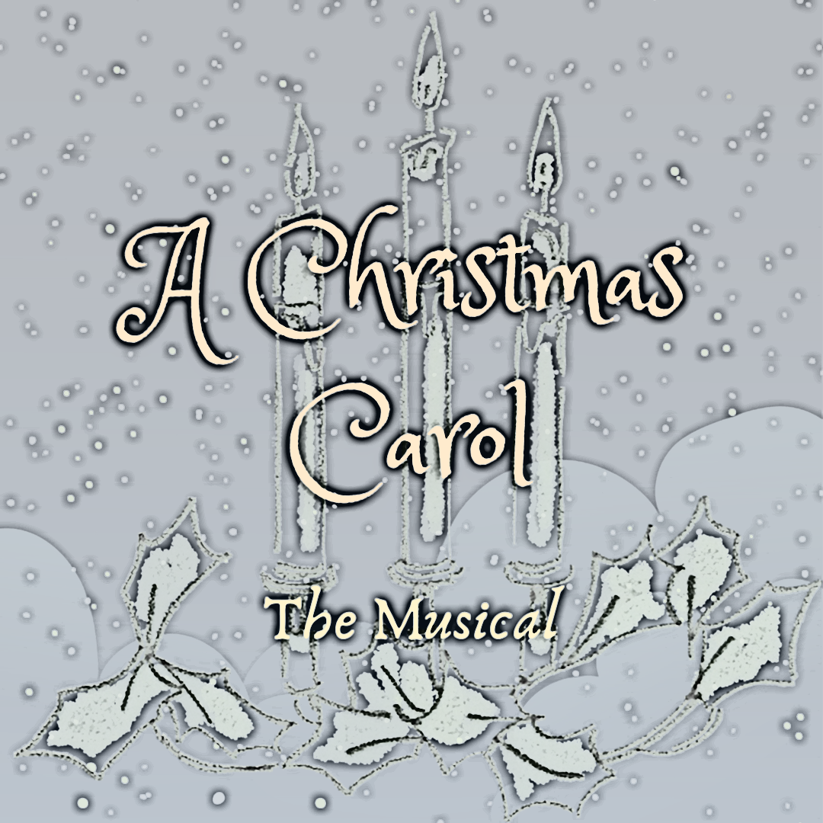

Student Performer: ____________________________
August 19 individual audition time: _______________

Sarasota High School Theatre Fall Musical Info Packet

Show/Dates: "A Christmas CAROL"- December 5-7, 2024
Ebenezer Scrooge is a prosperous curmudgeon who believes that personal wealth is far more valuable than the happiness and comfort of others. With an infuriated "Bah! Humbug!" Scrooge summates his feelings of Christmas tidings and charitable giving, but he's forced to face his selfish ways when three ghosts on Christmas Eve lead him through his Past, Present and Future. Thanks to their guidance, Scrooge recognizes his faults and greets Christmas morning with a cheerful "Happy Christmas" before spending the day reconnecting and sharing love with those that mean the most to him.
Audition dates:
Monday, August 19- Individual Auditions
Everyone must audition on this date. All performers are asked to prepare a short 1-3 minute monologue and sing 16 bars of a song of their choice.
Tuesday, August 20, 3-8pm- Dance call and callbacks
Everyone MUST attend the dance call from 3-4:30. If you are called back for a specific role, you will be given sides before you leave on Tuesday. Callbacks are from 4:30-8 pm and only those who are called back will need to stay.
How to audition:
1. Take a moment to read through our auditions disclaimer and check out an example of our production contract (included in this packet), that way you are familiar with the commitment we will be asking you to agree to. Look doable to you? Fabulous, now to the fun stuff!
2. All parents must sign the audition disclaimer to confirm they are aware of their student participating in “A Christmas Carol”.
3. Fill out the online audition application. You can find this at shstheater.com, under the “audition materials” tab in the Student Portal.
4. After you fill out your application, sign up for your five-minute audition time slot. (also on the website)
5. Choose a monologue to share with us at your audition. For this show, there are monologues on the website in the auditions tab for you to choose from. This monologue should be memorized if possible, but it's okay if it is not. (If you have previously performed with us in the past, we expect it to be memorized.) Be prepared to sing one of the 16 bars song choices from the musical that are listed on the website.
6. Fill out the conflict form. Bring this form with you on the day of auditions.

Please see Ms. K with any questions about our audition process. Break a leg, everyone!

A Christmas Carol Character Descriptions/Vocal Breakdowns

Please take note for the dance callback:
• Tumbling is a plus – if you can tumble or pull tricks, please share!
• Please wear character shoes, jazz shoes, or sneakers for the dance callback. You’ll likely be wearing dance shoes, character shoes, or dress shoes during the show.

Ebenezer Scrooge Male. Must be able to move. Grouchy old miser who has grown cold and mean-spirited. Through his journey with the three ghosts, he regains his kindness and goodwill.

Bob Cratchit Kind and patient, he endures Scrooge's temper and abuse to provide for his family, especially his son, Tiny Tim.

Ghost Of Christmas Past / Lamplighter Must be able to move gracefully. Joyful, comedic guide to Scrooge into his past. Cheerfulness and kindness are this characters dominant traits, and maybe a little zany. Very energetic.

Ghost of Christmas Present / Sandwichboard Man Preferably be able to tap dance or fake it well. Must be able to move. A larger than life, jovial character who shows Scrooge the present world around him. Very vaudeville.

Ghost of Christmas Future / Blind Old Hag Preferably able to belt with a strong mix. Must be able to move in a contemporary style. Creepy and eerie, yet captivating every time they are on stage.

Fred Anderson Nephew of Scrooge. Compassionate and joyful.

Ghost of Jacob Marley Must be able to move. The spirit of Scrooges old business partner. Good comedic timing.

Tiny Tim Son of Bob Cratchit. Walks with a cane. Represents the Christmas spirit with hope and goodness.

Fezziwig Must be able to move. Jolly and kind bank owner. Scrooge's past employer who helped him get his start.

Mrs. Cratchit Wife of Bob. Mother to Tiny Tim, Martha, and the other Cratchit children. Loving, hopeful, and generous.

Mrs. Fezziwig Must be able to move. Cheerful wife of Mr. Fezziwig. Fun and sassy.

Young Ebenezer Must be able to move. Scrooge with the happiness of his youth and deeply in love with Emily. Sincere, yet money driven.

Young Marley Must be able to move. Starts business with Scrooge at 18 and shares a similar mindset of greed.

Emily Must be able to move. A lovely girl. Enjoys the simple things in life. Joyful and kind hearted. In love with Scrooge at 18.

Mr. Smythe Recently widowed. Hopeful. Poor and in debt to Scrooge. Father of Grace.
Gracie Smythe Daughter of Mr. Smythe. Sad yet hopeful.

Martha Cratchit Daughter of Bob & Mrs. Cratchit, sister to Tiny Tim.
Sally Anderson The wife of Scrooge's nephew Fred. Tired of having "Uncle Scrooge" over for Christmas dinner each year.

Scrooge at 12 A poor orphan who works all day at a bootmaking factory. Tired of poverty, he vows to save his money and make his fortune. He desperately misses his parents and wants to find a home of his own.

Beadle A worker in the royal exchange bank

Old Joe A ragpicker who scavenges off the dead.

Jonathan Fun street urchin. Comedic.

Mrs. Mops Maid for Scrooge.

Scrooge's Mother Sings

Ensemble:
A large ensemble from which smaller roles will be cast such as : Judge, Scrooge at 8, Scrooge's father, Scrooge's mother, Mr. Hawkins, Fan at 10, charity men, townspeople, factory workers, gravediggers, etc.

A Christmas Carol Auditions Checklist
Use this to keep track of all you need to do to prepare for and audition for A Christmas Carol! (This is just for you to use, please do not turn this in to me. )

- Read the example of a production contract and familiarize yourself with what you will be committing to.
- Fill out online application
- Sign up for audition time slot
- Choose a monologue
- Choose music selection
- Memorize monologue
- Turn in parent auditions disclaimer at your audition
- Fill out conflict form, being clear and honest about any and all conflicts/scheduling issues
- Turn in conflict form at auditions

A Christmas Carol Auditions Disclaimer and Parent Permission Form

-Please understand that auditioning for a show here at SHS indicates that you are willing to put in a significant amount of time and effort with our program. Most shows rehearse at least four days a week, and that bumps up to every day during tech weeks (the last two weeks before a show goes up). Some nights/weekends may be required as well.

-We use a large panel of judges that includes teachers and alumni, as well as community members, to be sure the casting process is fair and equitable. Other factors considered during casting are: past production etiquette and behavior, grades, time needed off for other commitments outside of theatre, reliability, class behavior and etiquette, teacher recommendations, professionalism related to previous casting experiences, as well as countless other factors that parents and students are not aware of due to the sensitivity of subjects. We are proud of our casting choices over the years and stand by them with pride and integrity.

-Other requirements may include: Production fees, shop hours, mandatory fundraising, etc.

-All cast and crew are required to stay and strike the set closing night of the show.

Student name: ______________________________________________________

Please Initial if you agree:

_______I understand my student is auditioning for a high school production of “A Christmas Carol” at Sarasota High School. I understand these shows require after school commitment and I have read the example of a production contract and can agree to the requirements within.

______ I understand the staff, administration, and judging panel decisions are final, and that casting is done as fairly and equitably as possible.

______ If my student does not wish to accept the role they are offered, I understand they have 72 hours to decline without penalty. I understand SHS Theatre has a culture of respect and honor, and questioning casting choices, gossiping, or bullying staff and students after casting jeopardizes our theatre family.

____________________________ _______________________________ _____________
Parent/guardian Name Parent/guardian Signature Date

