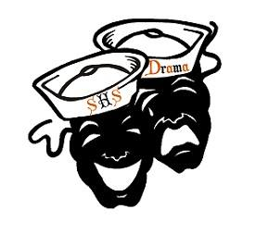

Sarasota High School Association of Dramatic Arts Boosters, Inc.
Thursday January 16, 2020

Welcome
- Treasurer report
- Booster fee - $10.00
- Teacher welcome
  - Debrief from White Christmas

- Website
  - www.shstheatre.com
    - Classes and afterschool information
    - Buy tickets
    - How to navigate the booster page/volunteer info
    - Your student is your best resource!

- Facebook
  - Join the SHS Theatre page
    - SHS Theatre Public page and our private page as well
      - Please like our Public page and give us a 5 star rating

- How to contact us
  - Parent boosters, text @shsada1920 to 81010
  - Please use email or remind to communicate with Mrs. K

- NYC TRIP
  - Performing arts trip
  - Student interest meeting tomorrow- January 17, after school
  - Parent meeting- Wednesday, January 22, 7pm

- Dinner Theater
  - Saturday, February 29, 6:30pm
  - Ticket on sale first week of February- $25 for dinner and a show

- Mamma Mia
  - General information
  - Schedule/conflict sheets
  - Production contract
  - Advertising- Special conditions
  - Props/special needs

  - Set Construction
    - 2/8, 2/22 (Jeff will not be here), 2/29, 3/7, 3/28
  - Show Dates :
    - 4/22 – 4/24 @ 7:00pm
    - 4/25 @ 2:00 pm and 7:00 pm

- Volunteer registration
  - Every person who is around the kids must have a background check
  - Please sign up as Sarasota County School volunteers website (see handout)
  - We need to do a check before the end of the year

- Sign-Up.com
  - How to sign up
    - Construction
    - Show meals
    - Publicity Committee
    - Pick Up/Errand Team
    - Gift Card Donation
    - Fundraising Committee
    - Costume Alterations/Sewing
    - Costume Measurement
(New signups will be on the website by next week, 1/21)
- Improv
  - March 5, 7pm, short form show. $5
  - “Tony ‘n’ Tina’s Wedding”- May 15, 7pm, $25

- All other important dates for the rest of the year can be found on the “Important Dates” printout

- Meeting adjourned

