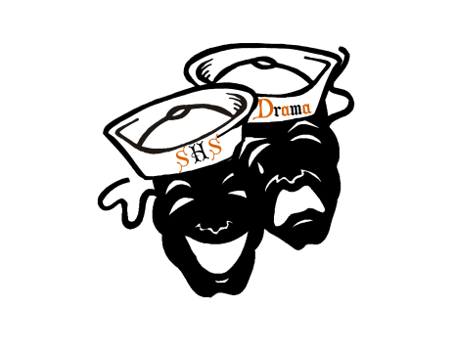
Sarasota High School Association of Dramatic Arts Boosters, Inc.
Wednesday August 23, 2017
Booster Meeting Agenda

Welcome
- Accepting the minutes.
- Treasurer report
- 2017 – 2018 Board Introductions
- Welcome
  - Introductions
    - Teachers
      - Committees
        - Thriller
        - Gag Awards Dance
        - Food
        - Community Ed Foundation
  - Parent Mandatory Involvement
- Website
  - www.shstheater.com
    - Classes and after school Information
    - Buy tickets
    - Shutterfly Picture Account
- Facebook
  - Everyone should get out their phones and join the SHS Theater page
    - SHS Theater Public page and our private page as well
      - Please like our public page and give us a 5 star rating
- Remind 101
  - There should be a handout with all the accounts on it.
      - SHSADA
        - Text: Enter this number 81010 test this message @theboos
      - To get Weekly schedule updates on Sunday’s
        - Text: Enter this number 81010 test this message @shsdra
- Booster Meetings
  - Less Meetings but same involvement
  - Sign-up.com
  - Collection of money (t-shirts, performance fees)
- Fall Show
  - Auditions
  - Show T-Shirts
    - $15.00
    - Orders are DUE: By no later than Friday September 18
  - Production Contract
    - Production Fee: $40.00
  - General Information
  - Show Dates:
    - 11/16, 11/17 @ 7:00pm
    - 11/18 @ 2:00pm and 7:00pm
- Fundraising
  - Carrabbas October 6 (Production fee for the fall show and upcoming productions)
    - Money and orders should be brought in weekly
      - Deadline Thursday October 4
  - Yankee Candle (Thriller Fees and Program wide fundraiser)
    - Start Date: October 10
    - End Date: November 7
    - Delivery date: 12/4 – 12/8
- Thriller
  - What is it?
  - Learn during class time
    - October 1 – 13
    - Audition Date: Friday October 13
      - Students will be notified on 10/13 at 2:30pm
        - On facebook, www.shstheater.com and posted on theater door
  - Thriller Mandatory Meeting
    - Tuesday October 17 at 7:00pm
      - Forms must be turned in
      - T-shirt (chaperone and participant) $15.00
  - Make-up Class
    - October 24 6:00pm – 8:00pm in the theater
      - You have to go through this class in order to help with makeup
  - Chaperones
    - Mandatory Chaperone Meeting
      - October 30 6:00pm @ St. Armand’s Circle Center
  - Performances
    - We are going to have to limit them because of bus fees
      - Possible Events
  - St. Armand’s Performance
    - Monday October 31
      - Makeup starts at 4:00am, parents are needed starting at 7:00am
        - Take 1 and ½ hours to get through make for each kid. We try and start 10 an hour.
        - Makeup parents can come in shifts through-out the day
          - 7:00am – 12:00pm / 12:00pm – 5:00pm
        - Chaperones do not have to be there until 4:30pm home by 9:30pm
  - No Picking up at St. Armand’s: Most Important Thriller Rule
- St. Armand’s Christmas Tree Dancers
  - Monday’s 5:00pm – 7:00pm
    - Start September 18, 2017
    - They must come with a partner
    - We will take everyone depending on numbers if we exceed 20 couples we will have to audition.
  - Performances
    - We will be performing at the SHS Drama Holiday Kick-Off December 8
    - We will be doing two or three dances down in St. Armand’s Circle as they light the tree
      - Friday December 1 4:00pm – 8:00pm
    - We will be doing two dances on the Holiday Float Down Main Street
      - Saturday December 2 4:00pm – 9:30pm

- Holiday Parade
  - Theme and Decoration
    - Circus Theme
    - Float Build Ideas Welcome
    - We need Christmas Lights
  - There is limited space on the float so we will have to wait and see how many we can get on it safely and then determine who goes
  - We are in desperate need of Candy Canes we need to collect 10,821 in order to tie last years total. We hand these out to the kids in the streets as the float drives by.
- Volunteer registration
  - Every person who is around the kids must have a background check
  - Forms: If you cannot get to school to register we do have forms you can fill out and enter for you. These forms will be kept confidential and shredded after they are entered
  - IMPORTANT WE MUST DO THIS
- Sign-Up.com
  - How to do it!
    - Chaperones for Thriller
    - Chaperones for Holiday Dance Team
    - Helpers for Construction
    - Chaperones for the performances of the fall show
    - Food Providers
    - Help with dinner for show nights
- Improv
  - Troupe Fee: $15.00
    - Includes Troupe T-Shirt
    - Due Tonight
  - First Show
    - September 13 7:00pm in the Theater

