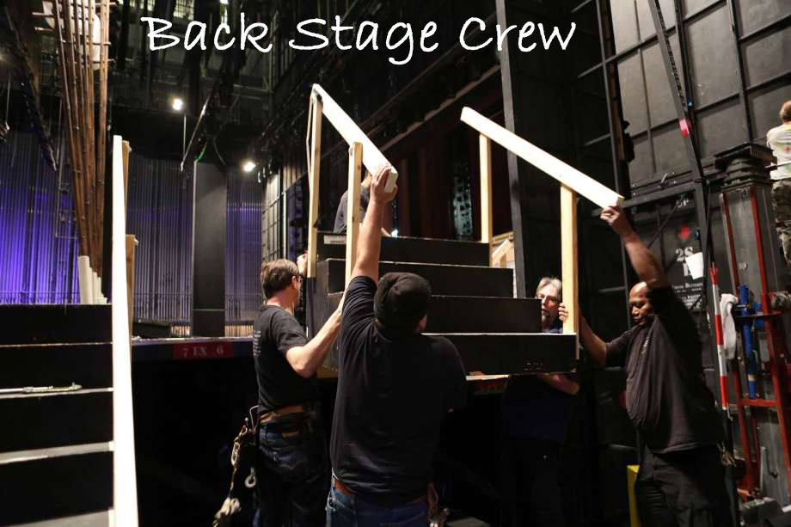

SPRING 2018 MUSICAL CREW

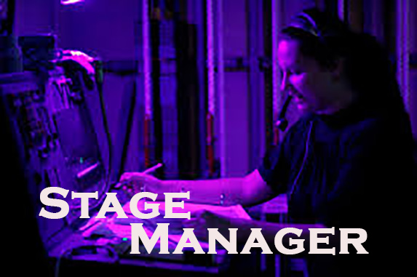

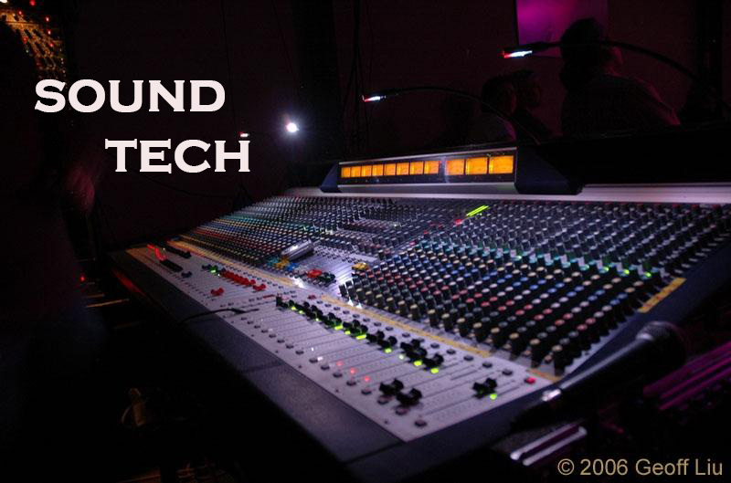

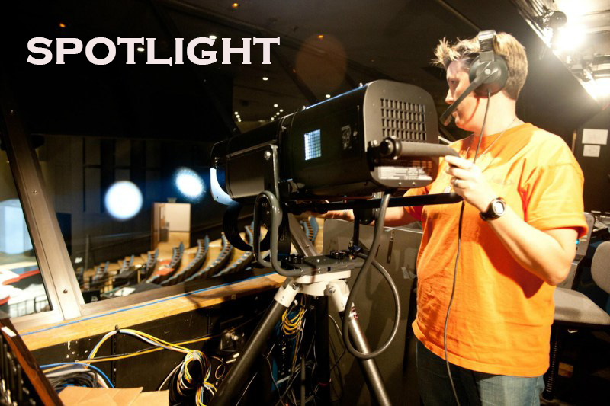

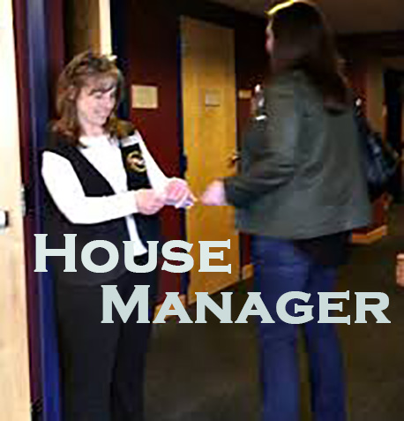

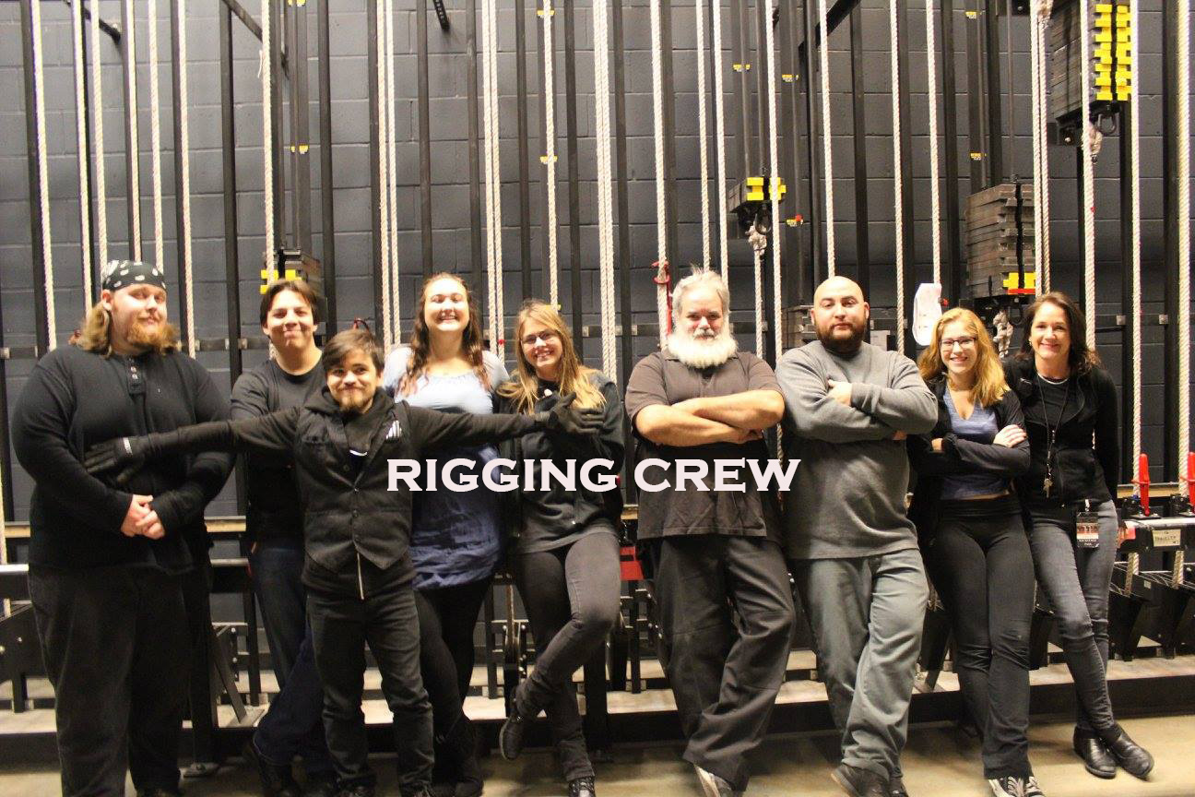

Welcome!

You’ve decided you’re interested in the world of tech and backstage. These are exciting positions that are essential to the production. Due to the importance of these positions you will be required to be as professional maintaining good grades as well as being able to attend rehearsals and the productions.
Below you will find information about the many positions available for the Spring Musical Crew. Please read carefully before submitting your application.

APPLICATION DUE DATE: Thursday December 21, 2017

Information

Rehearsals
*Dates are subject to change. You will receive an official schedule in February through email.

January 8 – April 21: All Rehearsals: Stage Manager
March 12 – April 21: Backstage Crew and Technical Crew (Lights, Sound and Spotlight
April 2 – April 21: House Manager
April 9 – April 21: Hair and Make-up
April 13 – April 21 Costumers
*Rigging TBA

Musical Performance Dates
Wednesday April 18: 7:00pm
Thursday April 19: 7:00pm
Friday April 20: 7:00pm
Saturday April 21: 2:00pm and 7:00pm

**All rehearsals the week before the show and the week of the show are mandatory if you miss a rehearsal you will be removed from the show.

Quitting/Failing Grades/ Attendance
Grades and attendance are an important factor in the process of the whole musical. Not being able to maintain your grades or attendance is unacceptable and will not be tolerated. The expected grades and attendance policies as well as any others are listed in the table below.

Grades: D’s & F’s Students will be removed from the show for a period of one week, during this
period they have to get their grades up above a 60.
During their one week absence they will hand in daily progress checks from their teacher(s) where they are receiving the failing grades.

Attendance: You cannot come to rehearsal when you miss a day of school. Missing too many
rehearsals mean that you cannot maintain your position, remember that an entire cast is depending on you. Missing 5 rehearsals due to absences from school in a four week period will have you removed from the show. This also includes attendance issues with the school day. On your Crossepoint you should also have a printout of your attendance excused, absent and tardys.

Quitting: If you quit or are removed from the show you will have to come in front of the
board of appeals and present reasons why you should be allowed in this
production for all the productions the next year. You can be denied the ability to
audition because of quitting or being removed.
Tech:
For students who are interested in working in the tech booth with either our lighting, spotlight or sound equipment. These positions are as essential to the production as the actors are. These students will be working with $250,000.00 worth of electrical equipment and must be prepared to learn how to operate and treat this equipment. The students will be running the tech from the box with adult supervision.

Administrative
The lead stage manager position is chosen by the Director with input from the Student Stage Manager Director. There are assistant stage manager positions available (there can be up to two of these depending on the size of the show and set. There is also a House Manager position that will actually be working with our Parent and Student Publicity Directors.

Property Chiefs
These students are in charge of the prop tables and must be responsible and organized.

Backstage
Students will be moving and adjusting scenery as well as setting the stage for scenes. You must have all BLACK clothing. Pants, socks and shirts in order to work backstage.

Costuming
If you are good a sewing or repairing costumes or would like to help with quick changes back stage this is the position for you.

Hair and Make-up
These students get to help create the character through designing and implementing hair and make-up choices

Rigging
This job involves heavy lifting. The students doing rigging will be required to raise and lower backdrops continuously through-put the show.

Ushers
During the musical seating for the performances is by ticket number and ushers will be expected to be able to seat audience members in seats as well as deal with other seating issues.

Sarasota High School
2018
Spring Musical

Name: ________________________________________
Grade: _______
Student Cell Phone Number: ___________________________________
Student Email Address: _______________________________________
Parent Cell Phone Number: _________________________________
Parent Email Address: _____________________________________

Are you in a Theater Class? YES NO
If yes which one:
Drama 1 Drama 2 Drama 3/4 Directing Improv Stage Craft

Are you involved in Band? YES NO

What is your after school schedule?
Time | Monday | Tuesday | Wednesday | Thursday | Friday
2:30pm:
3:00pm
3:30pm
4:00pm
4:30pm
5:00pm
5:30pm
6:00pm

What Shows are you interested in?
___ Ast. Stage Manager ___ House Manager ___ Hair
___ Costumer ___ Lighting Tech ___ Sound Tech
___ Rigging ___ Backstage Crew ___ Make-up
___ Spotlight

Have you ever run tech or worked one of the positions above? Please list all jobs and places you worked at. We may contact past teachers and theater directors. ________________________________
________________________________________________________________________________________________________________________________________________________________________________________________________________________________________________________________________________________________________________________________________________

Anything else we should know: _________________________________________________________
________________________________________________________________________________________________________________________________________________________________________________________________________________________________________________________________________________________________________________________________________________

I understand that I am applying for a tech or backstage position in the SHS 2018 Spring Musical and that I am not guaranteed a position. I also acknowledge that my parent/guardian and I have read the entire application packet and understand the requirements listed in the packet. I understand that if I receive a position that I will make ALL rehearsals and performances.

____________________________________
Student Signature

____________________________________
Parent Signature

_______________
Date

